A

Mini Project

On

**DEPRESSION DETECTION USING ECG**

(Submitted in partial fulfilment of the requirements for the award of Degree)

BACHELOR OF TECHNOLOGY

In

COMPUTER SCIENCE AND ENGINEERING

By

B.BASKAR RAJU (217R1A0513)

B.NARSIMHA (217R1A0507)

S.VINAYAK (217R1A0554)

Under the Guidance of

**MR.G.VINESH SHANKAR**

(Assistant Professor)



**DEPARTMENT OF COMPUTER SCIENCE AND ENGINEERING**

**CMR TECHNICAL CAMPUS**

**UGC AUTONOMOUS**

(Accredited by NAAC, NBA, Permanently Affiliated to JNTUH, Approved by AICTE, New Delhi)

Recognized Under Section 2(f) & 12(B) of the UGCAct. 1956,

Kandlakoya(V), Medchal Road, Hyderabad-501401.

**2021-2025**

**DEPARTMENT OF COMPUTER SCIENCE AND ENGINEERING**



**CERTIFICATE**

This is to certify that the project entitled “**DEPRESSION DETECTION USING ECG”** being submitted by **B. BASKAR RAJU (217R1A0513), B. NARSIMHA (217R1A0507), S. VINAYAK (217R1A0554)** in partial fulfilment of the requirements for the award of the degree of B.Tech in Computer Science and Engineering to the Jawaharlal Nehru Technological University Hyderabad, is a record of bonafide work carried out by him/her under our guidance and supervision during the year 2024-25.

The results embodied in this thesis have not been submitted to any other University Institute for the award of any degree or diploma.

**Mr. G. VINESH SHANKAR Dr. A. RAJI REDDY**

**Assistant Professor DIRECTOR**

**Internal Guide**

**Dr. N. BHASKAR EXTERNAL EXAMINER**

**HOD**

**Submitted for viva voice Examination held on____________________**

**ACKNOWLEGDEMENT**

A part from the efforts of us, the success of any project depends largely on the Encouragement and guidelines of many others. We take this opportunity to express our gratitude to the people who have been instrumental in the successful completion of this project. We take this opportunity to express my profound gratitude and deep regard to my guide.

**Mr.G.VINESH SHANKAR**, Assistant Professor for his exemplary guidance, monitoring And constant encouragement throughout the project work. The blessing, help and guidance given by him shall carry us a long way in the journey of life on which we are about to embark. We also take this opportunity to express a deep sense of gratitude to Project Review Committee (PRC) Coordinators: **Dr. J. Narasimharao, Dr. K. Maheswari, Dr. S. Suma, Mr. K. Ranjith Reddy** for their cordial support, valuable information and guidance, which helped us in Completing this task through various stages.

We are obliged to **Dr. A. Raji Reddy,** Director for being cooperative throughout the Course of this project. We would like to express our sincere gratitude to Sri. **Ch. Gopal Reddy,** Chairman for providing excellent infrastructure and a nice atmosphere throughout the course Of this project.

We are also thankful to **Dr. N. BHASKAR,** Head, Department of Computer Science And Engineering for providing encouragement and support for completing this project successfully.

The guidance and support received from all the members of CMR Technical Campus who contributed to the completion of the project we are their constant support and help.

Finally, we would like to this opportunity to thank our family for their constant encouragement, without which this assignment would not be completed. We sincerely acknowledge and thank all those who gave support directly and indirectly in the completion of this project

**B.BASKAR RAJU(217R1A0513)**

**B.NARSIMHA(217R1A0507)**

**S.VINAYAK(217R1A0554)**

**ABSTRACT**

At present, depression has become a main health burden in the world. However, there are many problems with the diagnosis of depression, such as low patient cooperation, subjective bias and low accuracy. Therefore, reliable and objective evaluation method is needed to achieve effective depression detection. Electroencephalogram (EEG) and eye movements (EMs) data have been widely used for depression detection due to their advantages of easy recording and non-invasion. This research proposes a content based ensemble method (CBEM) to promote the depression detection accuracy, both static and dynamic CBEM were discussed. In the proposed model, EEG or EMs dataset was divided into subsets by the context of the experiments, and then a majority vote strategy was used to determine the subjects’ label. The validation of the method is testified on two datasets which included free viewing eye tracking and resting-state EEG, and these two datasets have 36,34 subjects respectively. For these two datasets, CBEM achieves accuracies of 82.5% and 92.65% respectively. The results show that CBEM outperforms traditional classification methods. Our findings provide an effective solution for promoting the accuracy of depression identification, and provide an effective method for identification of depression, which in the future could be used for the auxiliary diagnosis of depression.

**LIST OF FIGURES**

|  |  |  |
| --- | --- | --- |
| **FIGURE NO** | **FIGURE NAME** | **PAGE NO** |
| Figure 3.1 | Project Architecture | 18 |
| Figure 3.2 | Use Case Diagram | 21 |
| Figure 3.2 | Class Diagram | 22 |
| Figure 3.2 | Sequence Diagram | 23 |
| Figure 3.2 | Activity Diagram | 24 |

**LIST OF SCREENSHOT**

|  |  |  |
| --- | --- | --- |
| **SCREENSHOT NO** | **SCREENSHOT NAME** | **PAGE NO** |
| Screenshot 5.1 | Upload Dataset | 29 |
| Screenshot 5.2 | Load Dataset | 29 |
| Screenshot 5.3 | Extract Features from Dataset | 30 |
| Screenshot 5.4 | Run Existing SVM Algorithm | 31 |
| Screenshot 5.5 | Run Propose CNN Algorithm | 31 |
| Screenshot 5.6 | Predict Depression from Test Signals | 32 |
| Screenshot 5.7 | Load Test Data | 32 |
| Screenshot 5.8 | See Prediction as Depressed or Normal | 33 |
| Screenshot 5.9 | Click on Comparison Graph | 33 |
| Screenshot 5.10 | See CNN and SVM values | 34 |

**TABLE OF CONTENT**

|  |  |  |  |  |
| --- | --- | --- | --- | --- |
| **ABSTRACT** | | | | 4 |
| **LIST OF FIGURES** | | | | 5 |
| **LIST OF SCREENSHOTS** | | | | 6 |
| **1.** | **INTRODUCTION** | | | 9 |
|  | 1.1 | PROJECT SCOPE | | 10 |
|  | 1.2 | PROJECT PURPOSE | | 11 |
|  | 1.3 | PROJECT FEATURES | | 11 |
| **2.** | **SYSTEM ANALYSIS** | | | 12 |
|  | 2.1 | PROBLEM DEFINITION | | 13 |
|  | 2.2 | EXISTING SYSTEM | | 14 |
|  |  | 2.2.1 | LIMITATIONS OF THE EXISTING SYSTEM | 14 |
|  | 2.3 | PROPOSED SYSTEM | | 14 |
|  |  | 2.3.1 | ADVANTAGES OF PROPOSED SYSTEM | 15 |
|  | 2.4 | FEASIBILITY STUDY | | 15 |
|  |  | 2.4.1 | ECONOMIC FESIBILITY | 15 |
|  |  | 2.4.2 | TECHNICAL FEASIBILITY | 15 |
|  |  | 2.4.3 | SOCIAL FEASIBILITY | 15 |
|  | 2.5 | HARDWARE & SOFTWARE REQUIREMENTS | | 16 |
|  |  | 2.5.1 | HARDWARE REQUIREMENTS | 16 |
|  |  | 2.5.2 | SOFTWARE REQUIREMENTS | 16 |
| **3.** | **ARCHITECTURE** | | | 17 |
|  | 3.1 | PROJECT ARCHITECTURE | | 18 |
|  | 3.2 | DESCRIPTION | | 19 |
|  | 3.3 | USE CASE DIAGRAM | | 21 |
|  | 3.4 | CLASS DIAGRAM | | 22 |
|  | 3.5 | SEQUENCE DIAGRAM | | 23 |
|  | 3.6 | ACTIVITY DIAGRAM | | 24 |
| **4.** | **IMPLEMENTATION** | | | 25 |
|  | 4.1 | MODULES | | 26 |
| **5.** | **SCREENSHOTS** | | | 28 |
| **6.** | **TESTING** | | | 35 |
|  | 6.1 | INTRODUCTION TO TESTING | | 35 |
|  | 6.2 | TYPES OF TESTING | | 35 |
|  |  | 6.2.1 | UNIT TESTING | 35 |
|  |  | 6.2.2 | INTEGRATION TESTING | 36 |
|  |  | 6.2.3 | FUNCTIONAL TESTING | 36 |
| **7.** | **CONCLUSION & FUTURE SCOPE** | | | 37 |
|  | 7.1 | PROJECT CONCLUSION | | 38 |
|  | 7.2 | FUTURE SCOPE | | 38 |
| **8.** | **REFERENCES** | | | 39 |
|  | 8.1 | REFERENCES | | 40 |
|  | 8.2 | WEBSITES | | 42 |
|  |  |  |  |  |

**1. INTRODUCTION**

**1.INTRODUCTION**

**1.1 PROJECT SCOPE**

This project, titled **“Depression Detection Using ECG”**, focuses on the development and evaluation of a system that applies machine learning algorithms to detect depression by analyzing Electrocardiogram (ECG) signals. Mental health disorders, particularly depression, can impact physiological processes, including heart function. This project aims to explore how patterns in ECG data can be linked to depressive states, thereby enhancing diagnosis through non-invasive methods.Electrocardiograms (ECG) are widely used in clinical practice to monitor heart activity. Recent research suggests that certain changes in heart rate variability (HRV) and other ECG-derived features could be indicative of mental health issues such as depression. However, existing methods for diagnosing depression mostly rely on subjective assessments like questionnaires, which can be time-consuming and may not be entirely accurate. By leveraging machine learning, this project aims to automatically identify depressive patterns in ECG data, addressing these limitations.

**1.2 PROJECT PURPOSE**

The purpose of this project is to develop a non-invasive and data-driven system for detecting depression through the analysis of electrocardiogram (ECG) signals. Traditional methods of diagnosing depression rely heavily on self-reported symptoms and clinical assessments, which can be subjective and time-consuming. By applying machine learning algorithms to ECG data, this project aims to provide an objective approach to identifying depressive states, leveraging physiological patterns such as heart rate variability (HRV) that are linked to mental health.

The project seeks to enhance mental health diagnostics by offering a supplementary tool that can detect depression early, accurately, and efficiently. By organizing and analyzing ECG data using machine learning techniques, the system will help clinicians in making more informed decisions, potentially improving treatment outcomes. This integration of ECG signal analysis with machine learning enables a more precise understanding of depression's physiological effects, facilitating early intervention and personalized care.

**1.3 PROJECT FEATURES**

The key features of this project focus on leveraging machine learning for depression detection through ECG signal analysis. The project involves preprocessing raw ECG data to eliminate noise, followed by extracting relevant physiological markers, such as heart rate variability (HRV) and other cardiac features, that may indicate depressive states. Machine learning techniques, including supervised methods like Support Vector Machines (SVM) and Random Forest, as well as deep learning algorithms like Convolutional Neural Networks (CNNs), will be applied to classify individuals as depressed or non-depressed. Emphasis is placed on evaluating model performance using metrics such as accuracy and precision, ensuring robustness and generalizability through cross-validation. Furthermore, the integration of AI into healthcare is a crucial aspect, with the potential to apply the system in real-world clinical settings, including wearable devices for continuous monitoring and real-time detection of depression. This comprehensive approach aims to provide an objective, non-invasive tool for enhancing mental health diagnostics.

**2.SYSTEM ANALYSIS**

**2.SYSTEM ANALYSIS**

**SYSTEM ANALYSIS**

The system for depression detection using ECG involves several critical aspects that ensure its effective functioning. The system begins with the collection of ECG signals from wearable devices or clinical machines, which are then processed to remove noise and normalize the data for analysis. One of the primary challenges is dealing with variability in ECG signals caused by different factors such as age, physical activity, and emotional state. The system applies advanced feature extraction techniques to identify relevant markers like heart rate variability (HRV), which are linked to depressive states. Machine learning models, including support vector machines (SVM), random forests, or deep learning algorithms like convolutional neural networks (CNNs), are employed to classify whether an individual is experiencing depression based on these features. Given that datasets might be imbalanced, with fewer instances of depression compared to non-depressed samples, the system addresses this by incorporating methods to handle class imbalance, ensuring fair and accurate predictions. Performance is a key focus, with evaluation metrics such as accuracy, precision, and recall used to fine-tune and validate the model, ensuring reliability.

Additionally, the system’s feasibility depends on the availability of high-quality data, which may come from public datasets or clinical sources, and its ability to process this data in real time, particularly in wearable applications. Scalability is achieved through cloud-based solutions, enabling the system to manage large datasets and multiple users. Privacy and security are also paramount, with the system ensuring encryption and compliance with regulations like HIPAA and GDPR to protect sensitive patient information. Potential risks, such as false positives or false negatives, are mitigated by providing clinicians with tools to verify the results. The system must remain adaptable, allowing for updates to its algorithms as new data and improved techniques become available, ensuring that it continues to provide accurate, non-invasive depression detection. This analysis underscores the importance of robust infrastructure, data quality, and careful model evaluation in creating a system capable of delivering meaningful insights in mental health diagnostics.

**2.1 PROBLEM DEFINITION**

Depression is a prevalent mental health disorder that affects millions of individuals worldwide, often leading to significant emotional, physical, and social consequences. Traditional methods for diagnosing depression largely rely on subjective self-reports, clinical interviews, and psychological assessments, which can introduce biases and variability in diagnosis. Furthermore, many individuals do not seek help due to the stigma associated with mental health issues, leading to underdiagnosis and inadequate treatment.

Given the growing understanding of the physiological indicators of mental health conditions, particularly through heart rate variability (HRV) and other cardiac signals, there is an opportunity to develop a more objective and non-invasive approach to diagnosing depression. This project aims to utilize electrocardiogram (ECG) data to detect patterns associated with depressive states, leveraging machine learning algorithms to analyze the complex relationships between ECG features and depression.

**2.2 EXISTING SYSTEM**

DEPRESSION is a common mental disorder that affects approximately more than 350 million people worldwide. Major depression significantly affects a person's family, personal relationships and other general health aspects. It is reported by the World Health Organization that depression will become the second leading cause of illness by the year 2020. However, the assessment methods of diagnosing depression rely almost exclusively on patientreported or clinical judgments of symptom severity. Current diagnostic techniques of depression have obvious disadvantages, which are associated with patient denial, poor sensitivity, subjective biases and inaccuracy. All these disadvantages make depression diagnosis a labor intensive work . Recently, machine learning approaches have been applied to bio-signals for depression detection. However, there is still a gap between the classification accuracy and the actual application scenarios.

**2.2.1 LIMITATIONS OF EXISTING SYSTEM**

1) Less accuracy

2)low Efficiency

**2.3 PROPOSED SYSTEM**

The results of the proposed ensemble methods CBEM showed its advantages in depression recognition using EEG and EMs, with correct classification rates of 82.50%±3.52% (Eye movements) and 92.65%±1.97% (Resting-state EEG). The results are higher than the results of traditional classification in all experiments mentioned in this paper, and in most cases, results of CBEM are almost higher than any result of data subsets except one subset of resting state EEG. To sum up, based on the consideration that different types of data samples should be treated discriminately and separately. CBEM gives us an accuracy promoting solution for the depression detection, making progress further on the automatic depression detection method.

**2.3.1 ADVANTAGES OF THE PROPOSED SYSTEM**

1) High accuracy

2)High efficiency

**2.4 FEASIBILITY STUDY**

The feasibility of the project is analyzed in this phase and business proposal is put forth with a very general plan for the project and some cost estimates. During system analysis the feasibility study of the proposed system is to be carried out. This is to ensure that the proposed system is not a burden to the company. For feasibility analysis, some understanding of the major requirements for the system is essential.

Three key considerations involved in the feasibility analysis are

* ECONOMICAL FEASIBILITY
* TECHNICAL FEASIBILITY
* SOCIAL FEASIBILITY

**2.4.1 ECONOMICAL FEASIBILITY**

This study is carried out to check the economic impact that the system will have on the organization. The amount of fund that the company can pour into the research and development of the system is limited. The expenditures must be justified. Thus the developed system as well within the budget and this was achieved because most of the technologies used are freely available. Only the customized products had to be purchased.

**2.4.2 TECHNICAL FEASIBILITY**

This study is carried out to check the technical feasibility, that is, the technical requirements of the system. Any system developed must not have a high demand on the available technical resources. This will lead to high demands on the available technical resources. This will lead to high demands being placed on the client. The developed system must have a modest requirement, as only minimal or null changes are required for implementing this system.

**2.4.3 SOCIAL FEASIBILITY**

The aspect of study is to check the level of acceptance of the system by the user. This includes the process of training the user to use the system efficiently. The user must not feel threatened by the system, instead must accept it as a necessity. The level of acceptance by the users solely depends on the methods that are employed to educate the user about the system and to make him familiar with it. His level of confidence must be raised so that he is also able to make some constructive criticism, which is welcomed, as he is the final user of the system.

**2.5 HARDWARE & SOFTWARE REQUIREMENTS**

**2.5.1 HARDWARE REQUIREMENTS:**

Hardware interfaces specifies the logical characteristics of each interface between the software product and the hardware components of the system. The following are some hardware requirements.

* System    :   i3 or above.
* Ram    :   4 GB.
* Hard Disk : 40 GB

**2.5.2 SOFTWARE REQUIREMENTS:**

Software Requirements specifies the logical characteristics of each interface and software components of the system. The following are some software requirements.

* Operating system   : Windows8 or Above.
* Coding Language  : python

**3. ARCHITECTURE**

**3. ARCHITECTURE**

**3.1 PROJECT ARCHITECTURE**

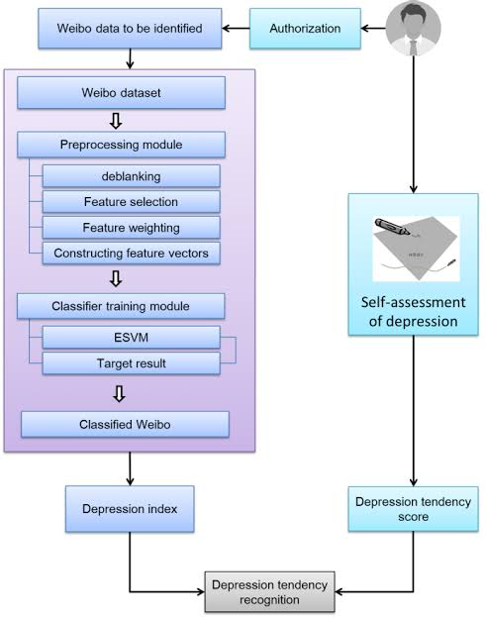

Figure 3.1 : Project Architecture of Depression Detection Using ECG

**3.2 DESCRIPTION**

The system architecture for detecting depression using ECG data comprises several interconnected components, each responsible for a specific function in the data processing, analysis, and classification pipeline. This architecture ensures smooth data flow from raw signal acquisition to the final prediction of depression status.

**1. Data Acquisition Layer**

* **ECG Sensors:** The system starts with the collection of ECG signals using wearable devices or clinical ECG machines. These devices capture raw electrical activity of the heart, providing continuous or session-based data.
* **Data Storage:** The raw ECG signals are stored in a structured database or cloud storage, where they are organized according to the patient ID, session information, and clinical depression diagnosis (if available).

**2. Data Preprocessing Layer**

* **Noise Removal:** The raw ECG signals often contain noise from external sources or body movement. The preprocessing component applies filtering techniques (such as Butterworth filters or wavelet transforms) to clean the signals.
* **Segmentation:** The ECG data is divided into meaningful segments based on heartbeats or fixed time windows for analysis.
* **Feature Scaling:** Normalization or standardization of data to ensure all features have comparable ranges for better model performance.

**3. Feature Extraction Layer**

* **Time-Domain Features:** Extract time-domain features such as heart rate, R-R intervals, and other significant points on the ECG waveform (P, Q, R, S, T points).
* **Frequency-Domain Features:** Apply techniques like Fourier transforms to extract frequency-related features such as power in different frequency bands, which may reflect variations in heart rate linked to depressive states.
* **Nonlinear Features:** Extract advanced features like heart rate variability (HRV), which has been shown to correlate with mental health conditions like depression.
* **Dimensionality Reduction:** Techniques such as Principal Component Analysis (PCA) may be applied to reduce the feature space, retaining only the most important features for depression classification.

**4. Model Training and Learning Layer**

* **Training Dataset:** A labeled dataset consisting of ECG signals and corresponding depression labels (depressed or non-depressed) is used to train the model.
* **Machine Learning Algorithms:** The system can implement various machine learning models. For supervised learning, algorithms like Support Vector Machines (SVM), Random Forest, or Neural Networks (e.g., CNNs, RNNs) are trained to classify depression status. For unsupervised learning, methods like K-Medoids clustering can be applied to group similar ECG signals and identify patterns linked to depression.
* **Cross-Validation:** To prevent overfitting and improve the generalizability of the model, cross-validation techniques are applied, ensuring robust performance across different data subsets.

**5. Model Evaluation and Optimization Layer**

* **Performance Metrics:** The system evaluates model performance using metrics such as accuracy, precision, recall, F1-score, and ROC-AUC to ensure the model is effectively identifying depression from ECG signals.
* **Hyperparameter Tuning:** Optimization of model parameters (e.g., number of clusters, learning rate, etc.) is done using techniques like grid search or random search to fine-tune the model and enhance its predictive power.

**6. Prediction and Decision Layer**

* **Real-Time Analysis:** Once trained, the model can process new ECG signals in real-time (or near real-time), classifying whether the person is likely experiencing depression based on the extracted features.
* **Decision Support:** The system outputs the depression probability score or binary classification (depressed vs. non-depressed) and can flag patients for further clinical evaluation if necessary. This decision can be integrated into clinical workflows or wearable monitoring systems for continuous mental health assessment.

**7. User Interface and Reporting Layer**

* **Clinician Dashboard**: The system provides a user-friendly dashboard where healthcare providers can view the patient's ECG data, feature analysis, and depression prediction. The interface allows for visualizing ECG trends and the system’s classification confidence over time.
* **Mobile/Wearable Integration:** If integrated with wearable ECG devices, the system can provide real-time depression monitoring and alerts to both patients and healthcare providers, allowing for timely interventions.

**3.3 USE CASE DIAGRAM**

A use case diagram in the Unified Modeling Language (UML) is a type of behavioral diagram defined by and created from a Use-case analysis. Its purpose is to present a graphical overview of the functionality provided by a system in terms of actors, their goals (represented as use cases), and any dependencies between those use cases. The main purpose of a use case diagram is to show what system functions are performed for which actor. Roles of the actors in the system can be depicted.

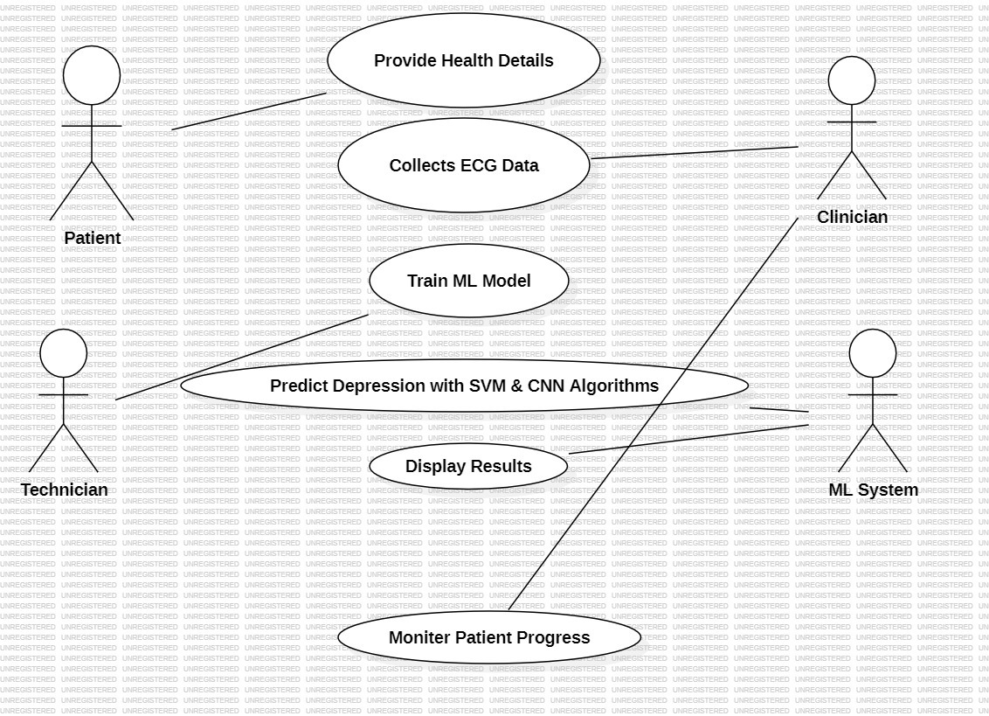

**Figure 3.3 :** Use CASE Diagram for Depression Detection Using ECG

**3.4 CLASS DIAGRAM**

In software engineering, a class diagram in the Unified Modeling Language (UML) is a type of static structure diagram that describes the structure of a system by showing the system's classes, their attributes, operations (or methods), and the relationships among the classes. It explains which class contains information.

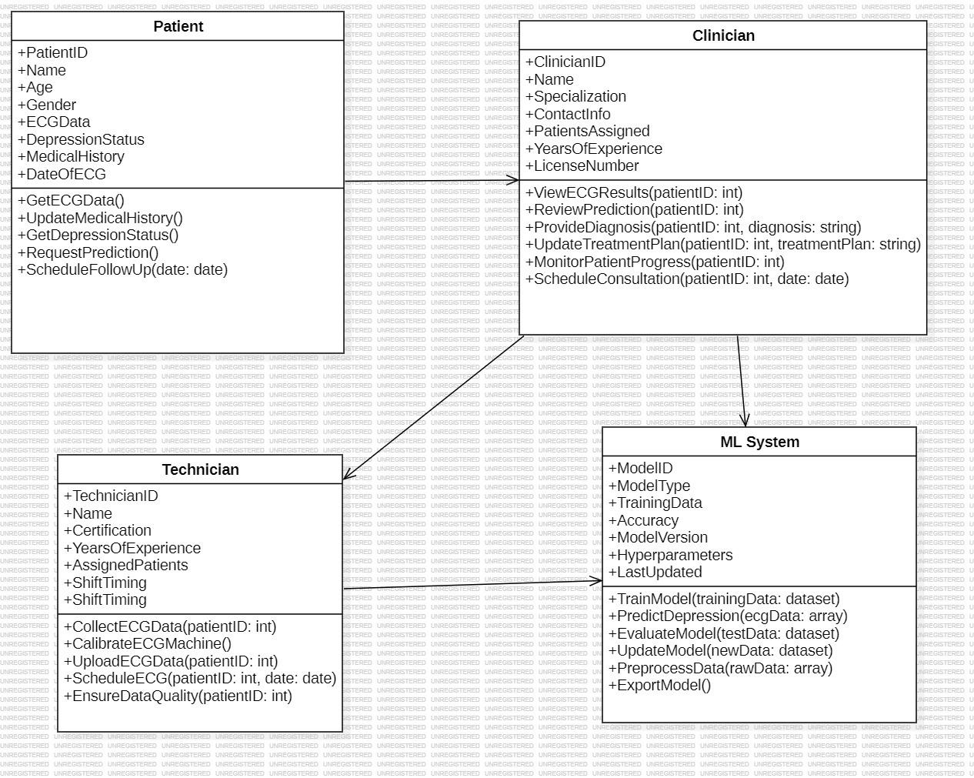

**Figure 3.4** : Class Diagram for Depression Detection Using ECG

**3.5 SEQUENCE DIAGRAM**

A sequence diagram in Unified Modeling Language (UML) is a kind of interaction diagram that shows how processes operate with one another and in what order. It is a construct of a Message Sequence Chart. Sequence diagrams are sometimes called event diagrams, event scenarios, and timing diagrams.

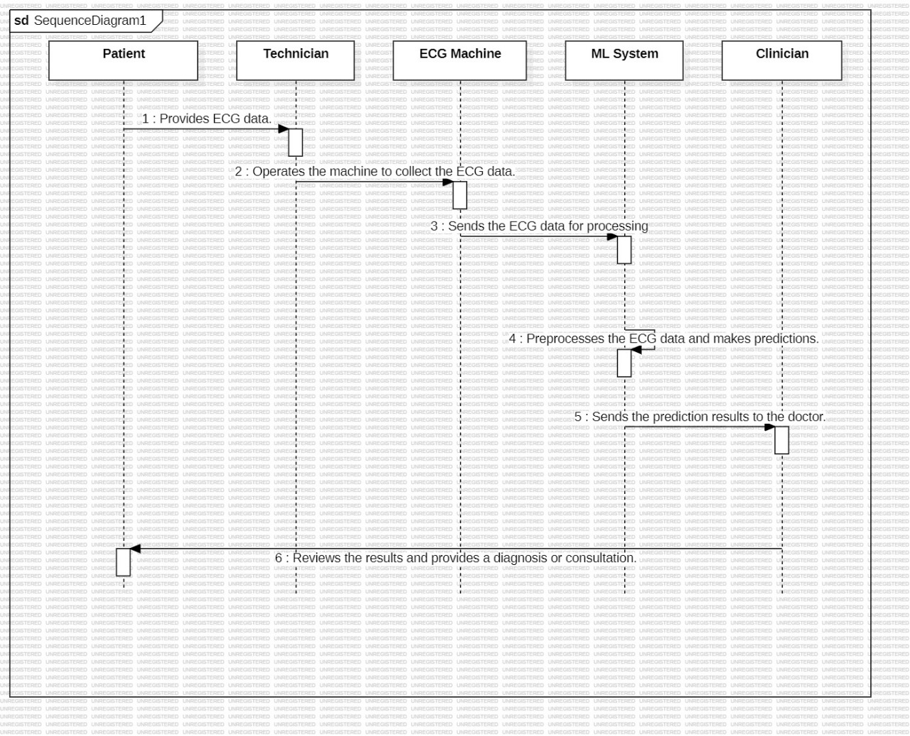

**Figure 3.5 :** Sequence Diagram for Depression Detection Using ECG

**3.6 ACTIVITY DIAGRAM**

Activity diagrams are graphical representations of workflows of stepwise activities and actions with support for choice, iteration and concurrency. In the Unified Modeling Language, activity diagrams can be used to describe the business and operational step-by-step workflows of components in a system. An activity diagram shows the overall flow of control.

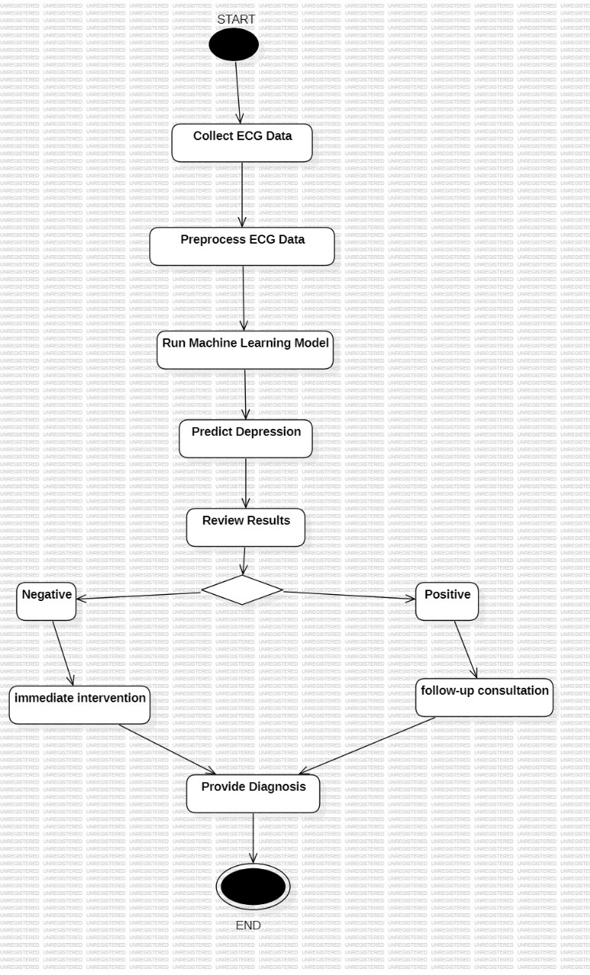

**Figure 3.5 :** Activity diagram for Depression Detection Using ECG

**4.IMPLEMENTATION**

**4. IMPLEMENTATION**

**4.1 MODULES:**

**1) Upload Shapes Dataset**

This module facilitates the upload of the shapes dataset into the application. Users can select files in various formats (such as CSV, JSON, or XML) containing shape data. The module ensures that the uploaded dataset adheres to the required structure, containing essential attributes such as unique identifiers, feature dimensions, and optional labels for evaluation. After successful upload, the application will confirm the data's integrity and readiness for preprocessing, ensuring a smooth transition to the next step.

**2) Preprocess & Hamming Distance Calculation**

In this module, the uploaded shapes are read and normalized to ensure that their values fall within a range of 0 to 1. This normalization process is crucial as it standardizes the features, making them comparable and mitigating the impact of varying scales. Following normalization, the Hamming distance is calculated between each pair of shapes. The Hamming distance, which measures the difference between two strings of equal length, will help assess the dissimilarity between binary representations of shapes. This metric is essential for clustering as it provides insights into how closely related the shapes are to each other, laying the groundwork for the subsequent clustering algorithm.

**3) Run K-Medoids Clustering Algorithm**

This module implements the K-Medoids clustering algorithm, utilizing both Hamming and Euclidean distances to identify similarities among shapes. Initially, the algorithm selects k initial medoids (central shapes) from the dataset. It then iteratively assigns each shape to the nearest medoid based on the calculated distances, ensuring that similar shapes are grouped together in the same cluster. This process continues until a stable state is reached, meaning that no further changes occur in cluster assignments, indicating that all shapes are optimally arranged. The algorithm not only enhances the efficiency of shape organization but also helps in minimizing the overall clustering cost, ensuring that the final clusters are representative of the dataset.

**4) Similar Shapes Visualization from Clusters**

In the final module, the application visualizes the shapes grouped in each cluster, allowing users to easily explore and analyze similar shapes. This visualization can take various forms, such as scatter plots, dendrograms, or gallery views, depending on the complexity and nature of the shapes. Each cluster is visually distinct, using color coding or labeling to enhance clarity. Additionally, users may have the option to interact with the visualization, such as filtering clusters or zooming in on specific shapes for detailed inspection. This module provides valuable insights into the clustering results, enabling users to understand the relationships between shapes and assess the clustering quality effectively.

**Sample Code:**

**__init__.py**

import pymysqlprint(pymysql.__file__)pymysql.install_as_MySQLdb()

**Admin.py**

from django.contrib import admin# Register your models here.

**Models.py**

import pymysqlprint(pymysql.__file__)pymysql.install_as_MySQLdb()

**Tests.py**

from django.test import TestCase# Create your tests here.

**settings.py**

import os# Build paths inside the project like this: os.path.join(BASE_DIR, ...)BASE_DIR = os.path.dirname(os.path.dirname(os.path.abspath(_file_)))# Quick-start development settings - unsuitable for production# See https://docs.djangoproject.com/en/2.2/howto/deployment/checklist/# SECURITY WARNING: keep the secret key used in production secret!SECRET_KEY = '%8f!97e_yfkjc*t1s2@p6f1z531f*fm0t@2dmo9p74q#!tza%u’# SECURITY WARNING: don't run with debug turned on in production!DEBUG = TrueALLOWED_HOSTS = []# Application definitionINSTALLED_APPS = [ 'django.contrib.admin', 'django.contrib.auth', 'django.contrib.contenttypes', 'django.contrib.sessions', 'django.contrib.messages', 'django.contrib.staticfiles', 'DepressionApp’]MIDDLEWARE = [ 'django.middleware.security.SecurityMiddleware', 'django.contrib.sessions.middleware.SessionMiddleware', 'django.middleware.common.CommonMiddleware', 'django.middleware.csrf.CsrfViewMiddleware', 'django.contrib.auth.middleware.AuthenticationMiddleware', 'django.contrib.messages.middleware.MessageMiddleware', 'django.middleware.clickjacking.XFrameOptionsMiddleware’,]ROOT_URLCONF = 'Depression.urls’TEMPLATES = [ { 'BACKEND': 'django.template.backends.django.DjangoTemplates', 'DIRS': [ os.path.join('C:/Python/Depression/DepressionApp', 'templates'), ], 'APP_DIRS': True, 'OPTIONS': { 'context_processors': [ 'django.template.context_processors.debug', 'django.template.context_processors.request', 'django.contrib.auth.context_processors.auth', 'django.contrib.messages.context_processors.messages', ], }, },]WSGI_APPLICATION = 'Depression.wsgi.application’CACHES = { 'default': { 'BACKEND': 'django.core.cache.backends.filebased.FileBasedCache', 'LOCATION': 'C:/cache/django_cache.txt', }}# Database# https://docs.djangoproject.com/en/2.2/ref/settings/#databasesDATABASES = { 'default': { 'ENGINE': 'django.db.backends.mysql', 'NAME': 'depression', 'HOST': '127.0.0.1', 'PORT': '3306', 'USER': 'root', 'PASSWORD': 'root', 'OPTIONS': { 'auto commit': True, }, }}# Password validation# https://docs.djangoproject.com/en/2.2/ref/settings/#auth-password-validatorsAUTH_PASSWORD_VALIDATORS = [ { 'NAME': 'django.contrib.auth.password_validation.UserAttributeSimilarityValidator', }, { 'NAME': 'django.contrib.auth.password_validation.MinimumLengthValidator', }, { 'NAME': 'django.contrib.auth.password_validation.CommonPasswordValidator', }, { 'NAME': 'django.contrib.auth.password_validation.NumericPasswordValidator', },]# Internationalization# https://docs.djangoproject.com/en/2.2/topics/i18n/LANGUAGE_CODE = 'en-us’TIME_ZONE = 'UTC’USE_I18N = TrueUSE_L10N = TrueUSE_TZ = True# Static files (CSS, JavaScript, Images)# https://docs.djangoproject.com/en/2.2/howto/static-files/STATIC_URL = '/static/'

**5.SCREENSHOTS**

**5.SCREENSHOTS**

To run project double click on ‘run.bat’ file to get below screen

**5.1 Upload EEG-Signal Dataset**

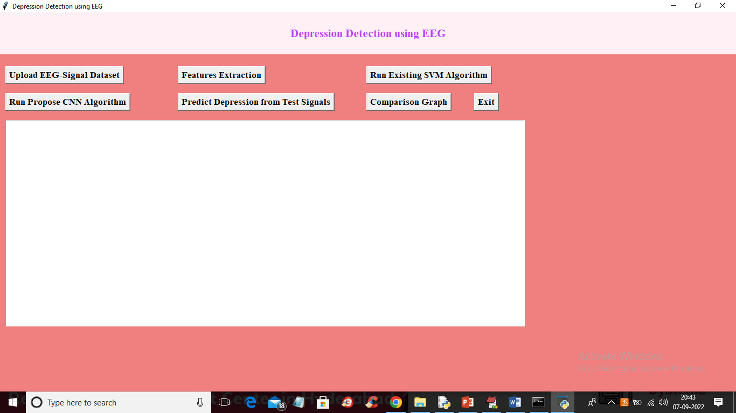

**Screenshot 5.1 :** In above screen click on ‘Upload EEG-Signal Dataset’ button to upload dataset and get below output

**5.2 Load Dataset**

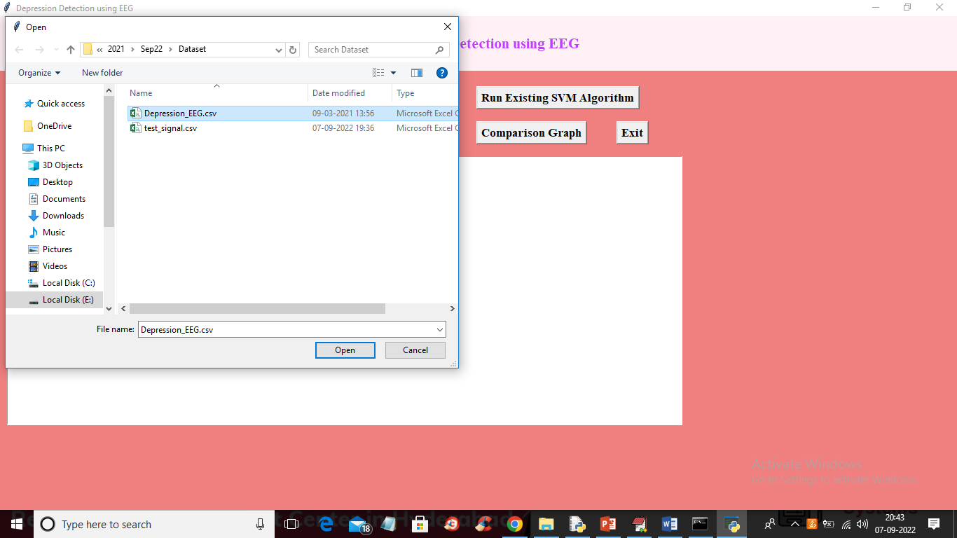

**Screenshot 5.2 :** In above screen selecting and uploading EEG-Signal dataset and then click on ‘Open’ button to load dataset and get below output

**5.3 Features Extraction**

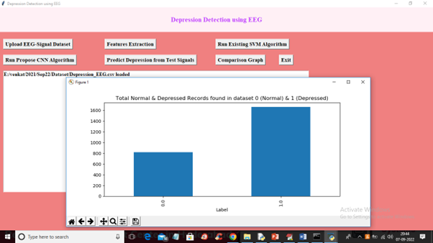

**Screenshot 5.3 :**In above screen dataset loaded and in graph x-axis represents labels as 0 or 1 where 0 means Normal and 1 means Depressed and y-axis represents counts of records and now close above graph and then click on ‘Features Extraction’ button to extract features from the dataset and get below output

**5.4 Run Existing SVM Algorithm**

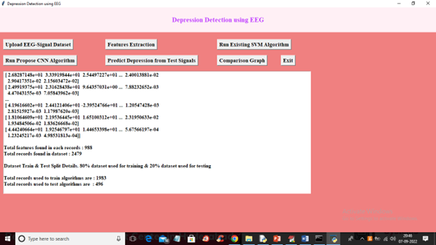

**Screenshot 5.4** : In above screen we can see extracted features and then each records contains 988 columns or features and dataset contains total records as 2479 and we can see train and test data details and now train and test data is ready for training. Now click on ‘Run Existing SVM Algorithm’ button to train SVM and get below output.

**5.5 Run Propose CNN Algorithm**

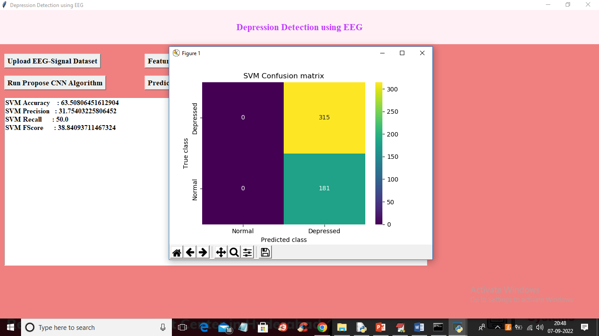

**Screenshot 5.5 :**In above screen with SVM we got 63% accuracy and in confusion matrix graph x-axis represents Predicted classes and y-axis contains TRUE classes and we can see SVM predicted all records as Depressed and its performance is not good and now close above graph and then click on ‘Run Propose CNN Algorithm’ button to train CNN and get below output

**5.1 Run Propose CNN Algorithm**

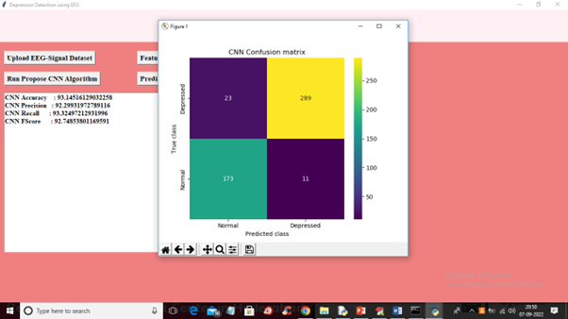

**Screenshot 5.6 :**In above screen with CNN we got 93% accuracy and in confusion matrix graph different colour boxes represents CORRECT prediction count and same colour boxes represents INCORRECT prediction count and CNN predicted only 23 and 11 as wrong prediction and 173 and 289 as correct prediction. Now close above graph and then click on ‘Predict Depression from Test Signals’ button to upload test data and get prediction output.

**5.7 predict output**

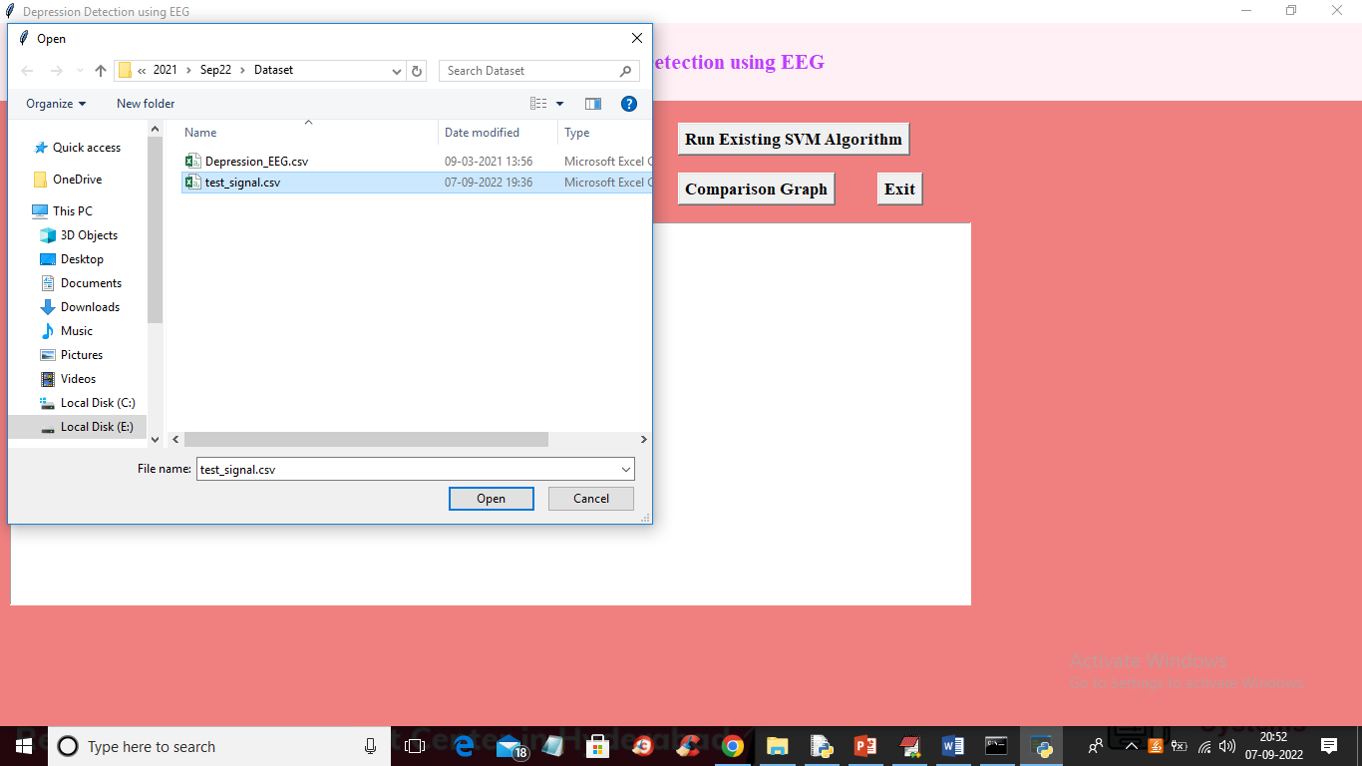

**Screenshot 5.7 :**In above screen selecting and uploading ‘test_signal.csv’ file and then press Open button to load test data and get below prediction output

**5.8 view all prediction output**

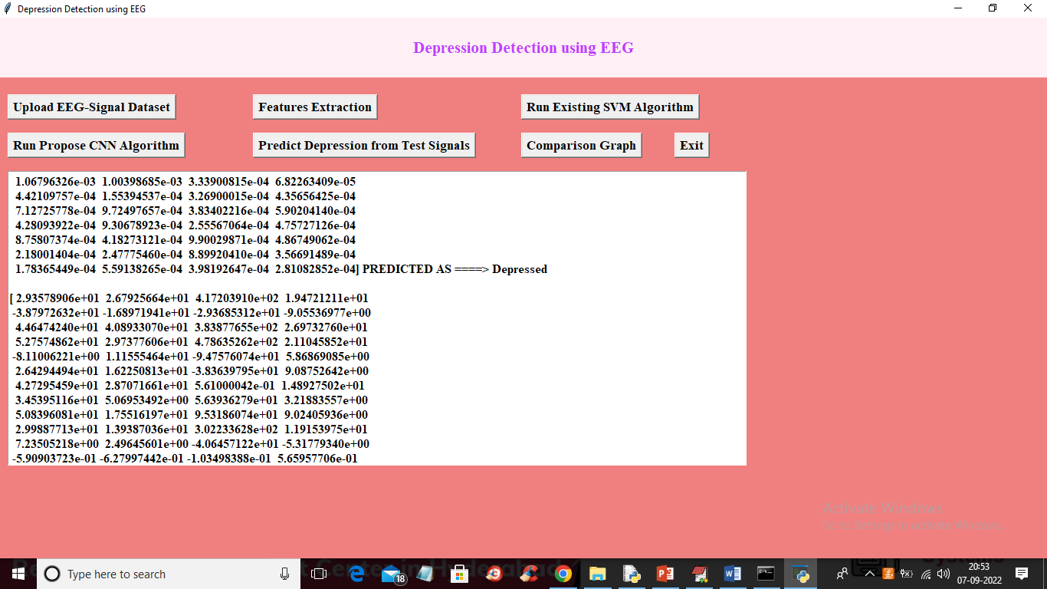

**Screenshot 5.8 :**In above screen in square bracket we can see TEST data values and after =🡺 symbol we can see prediction as Depressed or Normal and you can scroll above output screen to view all prediction output like below screen

**5.9 Comparison Graph**

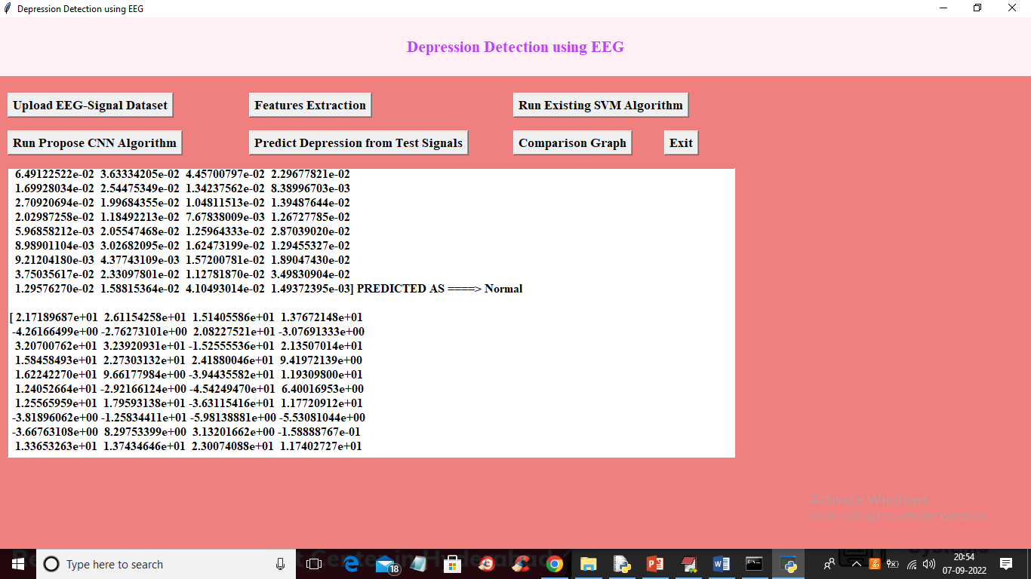

**Screenshot 5.9 :**Now click on ‘Comparison Graph’ button to get below graph

**5.10 Existing SVM & Propose CNN Performance Graph**

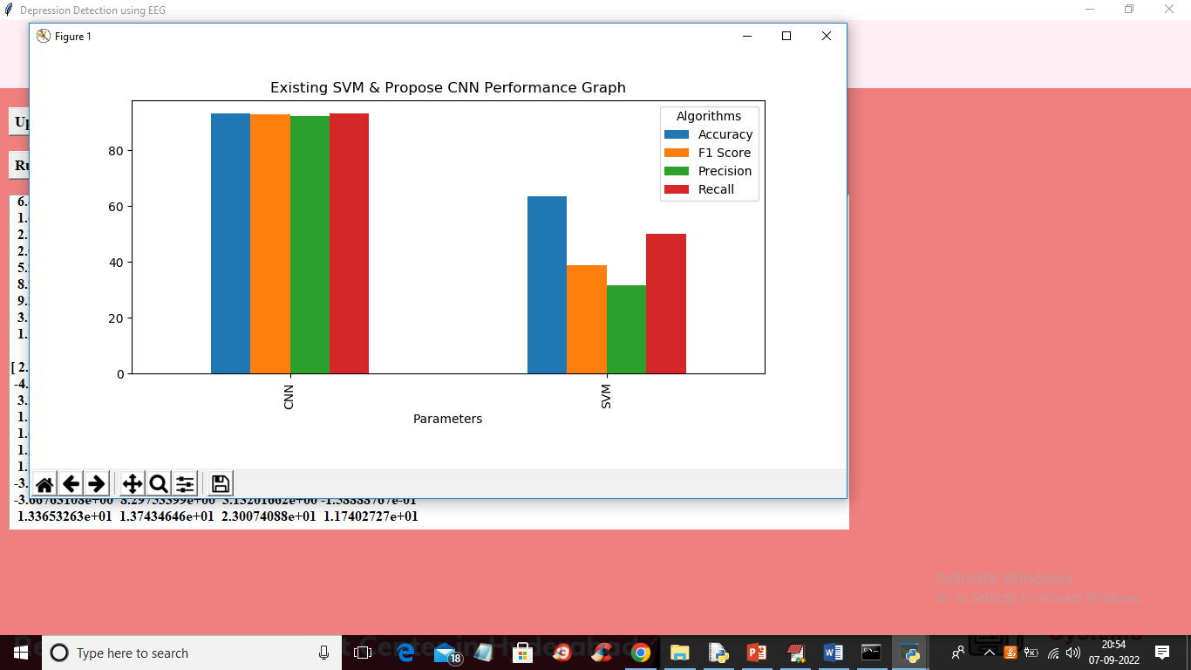

**Screenshot 5.10 :** In above graph x-axis represents algorithm names and y-axis represents accuracy, precision, recall and FSCORE in different colour bars and in above graph we can see CNN got high values compare to SVM

6. TESTING

**6. TESTING**

**6.1 INTRODUCTION OF TESTING**

The purpose of testing is to discover errors. Testing is the process of trying to discover every conceivable fault or weakness in a work product. It provides a way to check the functionality of components, sub assemblies, assemblies and/or a finished product It is the process of exercising software with the intent of ensuring that the Software system meets its requirements and user expectations and does not fail in an unacceptable manner. There are various types of test. Each test type addresses a specific testing requirement.

**6.2 TYPES OF TESTING**

**6.2.1 UNIT TESTING**

Unit testing involves the design of test cases that validate that the internal program logic is functioning properly, and that program inputs produce valid outputs. All decision branches and internal code flow should be validated. It is the testing of individual software units of the application .it is done after the completion of an individual unit before integration. This is a structural testing, that relies on knowledge of its construction and is invasive. Unit tests perform basic tests at component level and test a specific business process, application, and/or system configuration. Unit tests ensure that each unique path of a business process performs accurately to the documented specifications and contains clearly defined inputs and expected results.

**6.2.2 INTEGRATION TESTING**

Integration tests are designed to test integrated software components to determine if they actually run as one program. Testing is event driven and is more concerned with the basic outcome of screens or fields. Integration tests demonstrate that although the components were individually satisfaction, as shown by successfully unit testing, the combination of components is correct and consistent. Integration testing is specifically aimed at exposing the problems that arise from the combination of components.

**6.2.3 FUNCTIONAL TESTING**

Functional tests provide systematic demonstrations that functions tested are available as specified by the business and technical requirements, system documentation, and user manuals.

Functional testing is centered on the following items:

Valid Input : identified classes of valid input must be accepted.

Invalid Input : identified classes of invalid input must be rejected.

Functions : identified functions must be exercised.

Output : identified classes of application outputs must be exercised.

Systems/Procedures : interfacing systems or procedures must be invoked.

Organization and preparation of functional tests is focused on requirements, key functions, or special test cases. In addition, systematic coverage pertaining to identify Business process flows; data fields, predefined processes, and successive processes must be considered for testing. Before functional testing is complete, additional tests are identified and the effective value of current tests is determined.

**7. CONCLUSION**

**7. CONCLUSION AND FUTURE SCOPE**

**7.1 PROJECT CONCLUSION**

we can see that the CBEM in this paper achieves better results than the traditional classification. The CBEM tends to be more accurate than their component classifiers except in the resting-state EEG data, some data subsets of resting-state EEG achieved a higher accuracy than the CBEM (dynamic). Many classification accuracies of the subsets are also higher than the results of traditional classification. The apparent accuracies variation among divided data subsets gives us the evidence of the reasonability that we divided data into different subsets and applied different classification algorithms to them. The quite different classification accuracies among divided data subsets are also the fundamental factor that we choose to use some subsets instead of using all subsets for voting. By making the locally optimal choice to find a global optimum. As seen in the table 8, the Random Forest, SVM and KNN classifiers are better than other algorithms, most data subsets using these three algorithms achieve the best classification results and this phenomenon are same with the relative studies both in eye tracking and EEG [9, 16,17, 51].

Compared with the EEG experiment, the eye tracking experiment gets the higher FN (false negative, the depressed person labeled with healthy person) values of 3.70± 0.90 and 4.80± 0.75 respectively in static model and dynamic model. In these two experiments, static models’ FN values are lower than the FN values of dynamic models. Table 10 shows the results of significance tests on traditional classification methods and CEBM. Firstly, we will talk about the integrated data and the non-integrated data. Except in the eye tracking experiment, the integrated data and the non-integrated data didn’t show a significant difference. Secondly, the static and dynamic models of CBEM show a significant difference in all experiments.

**7.2 FUTURE SCOPE**

In the future, with the purpose of better understanding EEG and EMs data in the domain of depression recognition, we will continually explore efficient bio-signal data mining methods, especially, we will dedicate to improve the ensemble method, and explore new strategy to alternate the existing voting system.

**8.BIBLIOGRAPHY**

**8.BIBILOGRAPHY**

**8.1 REFERENCES**

[1]M. Marcus, M. T. Yasamy, M. van Ommeren, D. Chisholm, and S. Saxena, “Depression: A global public health concern,” WHO Department of Mental Health and Substance Abusevol. 1, pp. 6-8, 2012.

[2] G. H. Brundtland, “Mental health: new understanding, new hope,” Jama, vol. 286, no. 19, pp. 2391-2391, 2001.

[3] J. C. Mundt, P. J. Snyder, M. S. Cannizzaro, K. Chappie, and D. S. Geralts, “Voice acoustic measures of depression severity and treatment response collected via interactive voice response (IVR) technology,” Journal of neurolinguistics, vol. 20, no. 1, pp. 50-64, 2007.

[4] M. Sung, C. Marci, and A. Pentland, “Objective physiological and behavioral measures for identifying and tracking depression state in clinically depressed patients,” Massachusetts Institute of Technology Media Laboratory, Cambridge, MA, Tech. Rep. TR, vol. 595, 2005.

[5] L. Liu, R. Zhou, and D. O. Psychology, “An Important Neural Indicator of Measuring Depression: The Asymmetry of Resting Frontal Activity,” Advances in Psychological Science, vol. 23, no. 6, pp. 1000, 2015.

[6] J. Joshi, R. Goecke, S. Alghowinem, A. Dhall, M. Wagner, J. Epps, G. Parker, and M. Breakspear, “Multimodal assistive technologies for depression diagnosis and monitoring,” Journal on Multimodal User Interfaces, vol. 7, no. 3, pp. 217-228, 2013.

[7] P. Giannakopoulos, P. Missonnier, G. Gold, and A. Michon, “Electrophysiological Markers of Rapid Cognitive Decline in Mild Cognitive Impairment,” Frontiers of Neurology & Neuroscience, vol. 24, pp. 39, 2009.

[8] G. M. BAIRY, U. C. NIRANJAN, and S. D. PUTHANKATTIL, “AUTOMATED CLASSIFICATION OF DEPRESSION EEG SIGNALS USING WAVELET ENTROPIES AND ENERGIES,” Journal of Mechanics in Medicine & Biology, vol. 16, no. 03, pp. 13 pages, 2016.

[9] X. Li, B. Hu, S. Sun, and H. Cai, “EEG-based mild depressive detection using feature selection methods and classifiers,” Computer methods and programs in biomedicine, vol. 136, pp. 151-161, 2016.

[10] Mahato, S., & Paul, S. (2020). Classification of Depression Patients and Normal Subjects Based on Electroencephalogram (EEG) Signal Using Alpha Power and Theta Asymmetry. Journal of Medical Systems, 44(1), 28.

[11] Mahato, S., & Paul, S. (2019). Detection of major depressive disorder using linear and non-linear features from EEG signals. Microsystem Technologies, 25(3), 1065-1076.

[12] Ay, B., Yildirim, O., Talo, M., Baloglu, U. B., Aydin, G., Puthankattil, S. D., & Acharya, U. R. (2019). Automated depression detection using deep representation and sequence learning with EEG signals. Journal of medical systems, 43(7), 205.

[13] Li, X., La, R., Wang, Y., Niu, J., Zeng, S., Sun, S., & Zhu, J. (2019). EEG-based mild depression recognition using convolutional neural network. Medical & biological engineering & computing, 57(6), 1341-1352.

[14] T. Armstrong, and B. O. Olatunji, “Eye tracking of attention in the affective disorders: A meta-analytic review and synthesis,” Clinical psychology review, vol. 32, no. 8, pp. 704-723, 2012.

[15] E. H. Koster, E. De Lissnyder, N. Derakshan, and R. De Raedt, “Understanding depressive rumination from a cognitive science perspective: The impaired disengagement hypothesis,” Clinical psychology review, vol. 31, no. 1, pp. 138-145, 2011.

[16] X. Li, T. Cao, S. Sun, B. Hu, and M. Ratcliffe, "Classification study on eye movement data: Towards a new approach in depression detection." pp. 1227-1232.

[17] S. Alghowinem, R. Goecke, M. Wagner, G. Parker, and M. Breakspear, "Eye movement analysis for depression detection." pp. 4220-4224.

[18] Li, M., Cao, L., Zhai, Q., Li, P., Liu, S., Li, R., ... & Lu, S. (2020). Method of Depression Classification Based on Behavioral and Physiological Signals of Eye Movement. Complexity, 2020.

[19] Pan, Z., Ma, H., Zhang, L., & Wang, Y. (2019, September). Depression Detection Based on Reaction Time and Eye Movement. In 2019 IEEE International Conference on Image Processing (ICIP) (pp. 2184-2188). IEEE.

[20] J. Han, J. Pei, and M. Kamber, Data mining: concepts and techniques: Elsevier, 2011.

[21] L. Breiman, “Bagging predictors,” Machine Learning, vol. 24, no. 2, pp. 123-140, 1996.

[22] R. W. Johnson, “An Introduction to the Bootstrap,” Teaching Statistics, vol. 23, no. 2, pp. 49–54, 2001.

[23] T. H. Cormen, C. E. Leiserson, R. L. Rivest, and C. Stein, “Introduction to Algorithms, second edition,” pp. 1297–1305, 2001.

[24] S. Alghowinem, R. Goecke, M. Wagner, J. Epps, M. Hyett, G. Parker, and M. Breakspear, “Multimodal Depression Detection:Fusion Analysis of Paralinguistic, Head Pose and Eye Gaze Behaviors,” IEEE Transactions on Affective Computing, vol. PP, no. 99, pp. 1-1, 2017.

[25] L. Wen, X. Li, G. Guo, and Y. Zhu, “Automated Depression Diagnosis Based on Facial Dynamic Analysis and Sparse Coding,” IEEE Transactions on Information Forensics & Security, vol. 10, no. 7, pp. 1432-1441, 2015.

[26] K. J. Xiuzhuang Zhou, Yuanyuan Shang, “Visually Interpretable Representation Learning for Depression Recognition from Facial Images,” IEEE Transactions on Affective Computing, 2018.

[27] S. Lu, J. Xu, M. Li, J. Xue, X. Lu, L. Feng, B. Fu, G. Wang, N. Zhong, and B. Hu, “Attentional bias scores in patients with depression and effects of age: a controlled, eyetracking study,” Journal of International Medical Research, vol. 45, no. 5, pp. 1518-1527, 2017.

[28] T. Vervoort, Z. Trost, K. M. Prkachin, and S. C. Mueller, “Attentional processing of other's facial display of pain: an eye tracking study,” Pain, vol. 154, no. 6, pp. 836, 2013.

[29] A. Duque, and C. Vázquez, “Double attention bias for positive and negative emotional faces in clinical depression: Evidence from an eye-tracking study,” Journal of Behavior Therapy & Experimental Psychiatry, vol. 46, pp. 107, 2015.

[30] N. Tottenham, J. W. Tanaka, A. C. Leon, T. McCarry, M. Nurse, T. A. Hare, D. J. Marcus, A. Westerlund, B. Casey, and C. Nelson, “The NimStim set of facial expressions: judgments from untrained research participants,” Psychiatry research, vol. 168, no. 3, pp. 242-249, 2009.

1

**8.2 WEBSITES**

<https://ieeexplore.ieee.org/document/10170067>